**How to enable backup from Server to Recovery Service Vault**

**Step:1** In Azure portal, Navigate to **Recovery Service Vault** and then Click **ADD.**

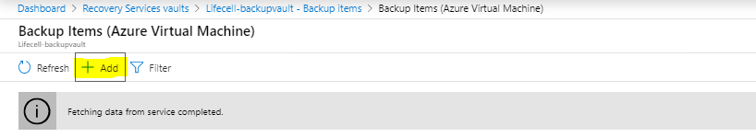

**Step :2** Backup Goal will display from there choose **Azure** in workload running and **Virtual Machine** in backup. Then Select **Backup.**

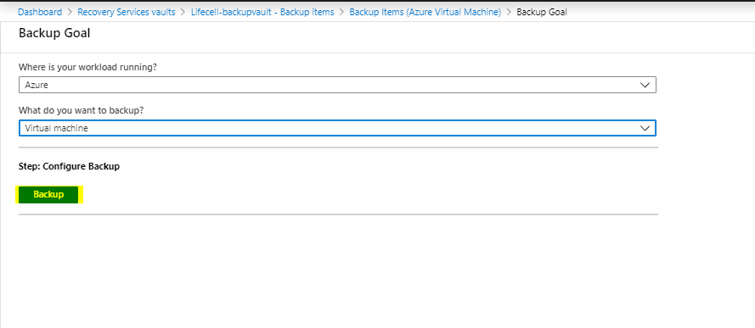

**Step :3** Once you select Backup, Backup Policy window will appear. Choose the **Backup Policy** and then click **OK**.

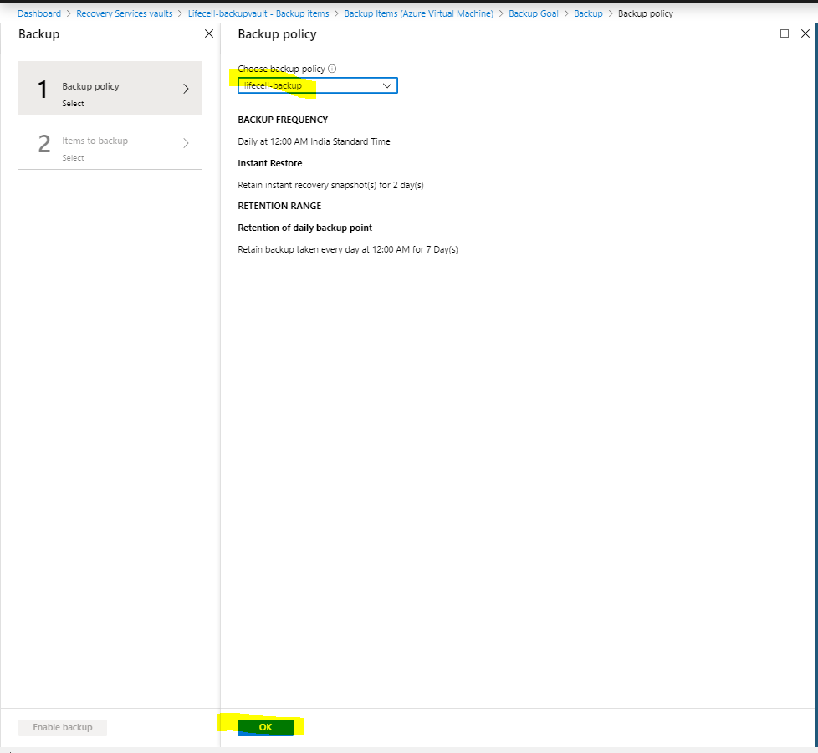

**Step :4** Once you select the Backup Policy, We have to select the **Virtual Machine** which we want to configure Backup.

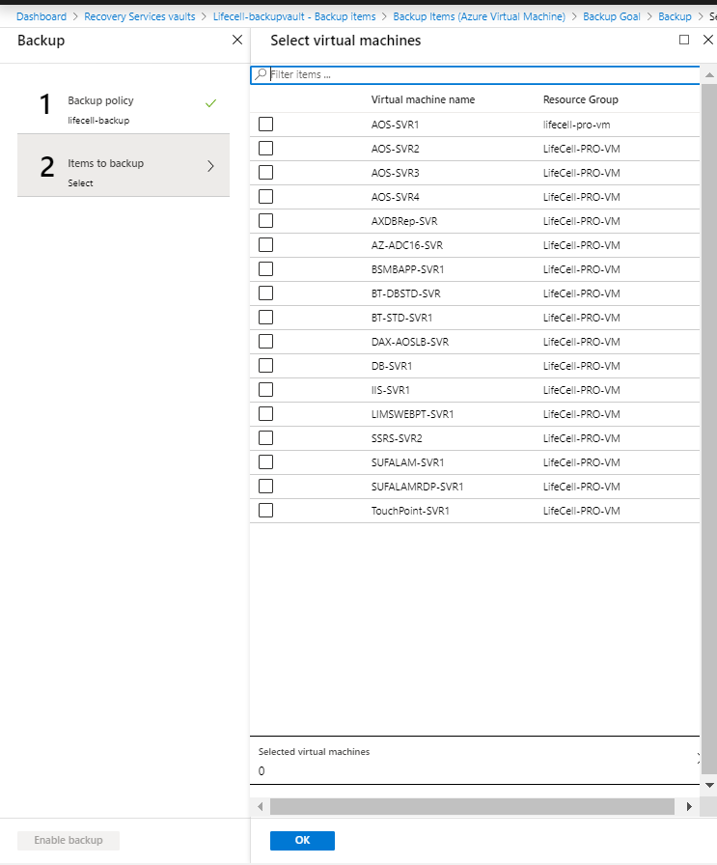

**Step :5** Once we select the Machines, Click **Ok** to enable backup**.**

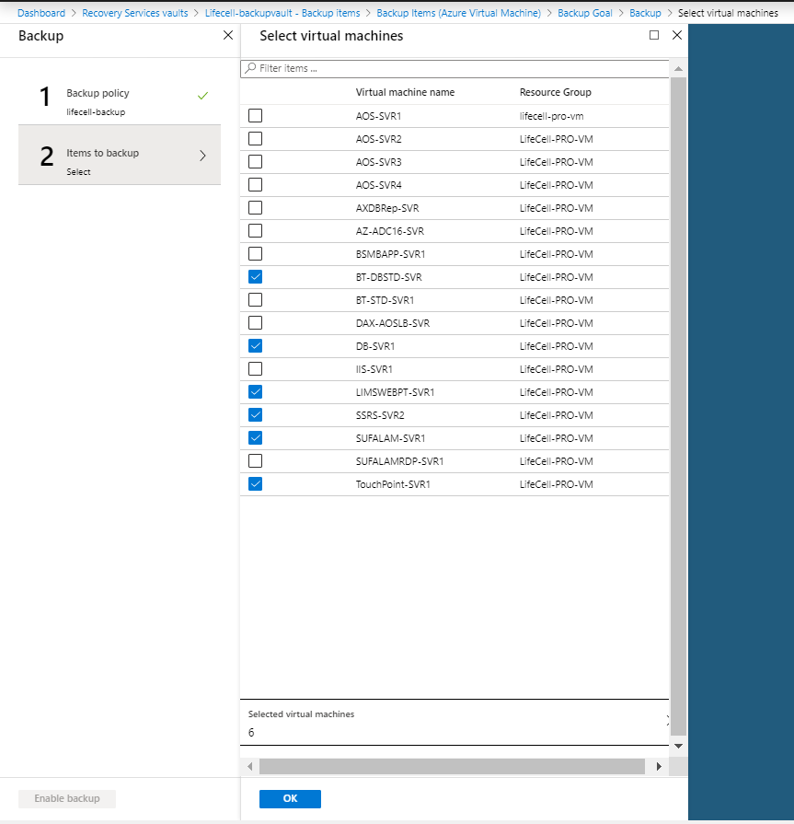

**Step :6** Click **Enable Backup** to Complete the process.

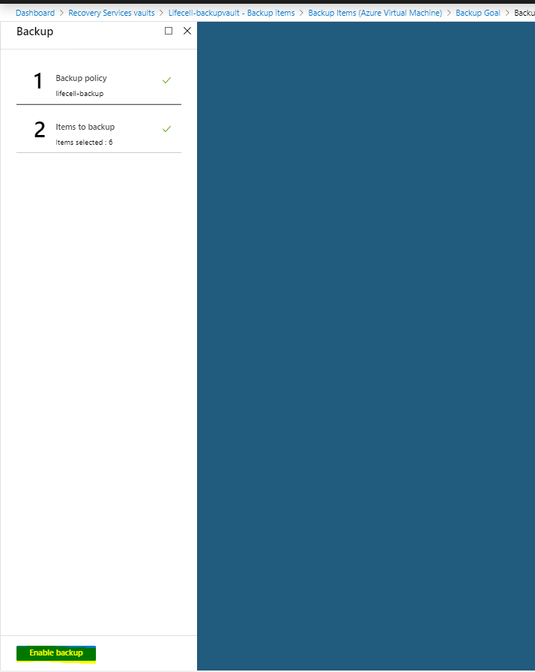

Once it was completed, the selected Machines will show when you select the **Backup Items** in the **Recovery Service Vault.**

